# The Link Layer

## Link Layer State Machine

Five states:

* Standby
* Advertising
* Scanning
  + active scanning
  + passive scanning
* Initiating
* Connection
  + master
  + slave

### Standby State

When powered on, the device starts in the standby state and remains there until the host layer says otherwise.

### Advertising State

Allows the Link Layer to transmit advertising packets. It can also respond to scan requests from devices that are actively scanning by sending a scan response. The advertising state is required if a device wants to be discoverable or connectable.

### Scanning State

A device will receive advertising channel packets. This could be used to simply listen to see what devices are advertising in the local area. Scanning is composed of two different substates: passive scanning and active scanning. Passive scanning only receives advertising packets. Active scanning also sends scan requests to advertising devices to obtain additional scan response data. While in passive scan state, the device never transmits anything. While in active scanning state, whenever a new device is discovered by the Link Layer, a scan request is sent to the advertising device, and a scan response is expected in reply. Both packets sent on advertising channel. Data in response must be mostly static.

### Initiating State

To initiate a connection to another device, the Link Layer must first be placed into the initiating state. In the initiating state, the receiver is used to listen for the device to which the initiator is attempting to connect. If an advertising packet form this device is received, the Link Layer will send a connect request to the advertiser and move into the connection state, in the assumption that the advertising device does the same.

### Connection State

The connection state is entered by an initiating device sending a connect request packet to an advertising device. In the connection state, data channel packets are sent and received between the two devices. This is the only state in which the data channels are used; all other states use the advertising channels. If the connection is terminated, the Link Layer moves into the Standby state.

The master connection substate can only be entered from the initiating state. A device that becomes a master must initiate the connection to the peer device. When a device is a master, it must transmit packets to the slave at regular intervals. This provides the slave with opportunities to reply and send its own data. A device can be the master of multiple slaves.

The slave connection substate can only be entered from the advertising state. When a device is a slave, it cannot transmit anything until a packet from the master is received correctly. Slaves can save power by just ignoring the master at any time. A device cannot be the slave of two masters at the same time.

## Packets

### Advertising and Data Packets

Two types of packets: advertising and data packets. The difference between advertising packets and data packets is that a data packet is understandable by only two devices (master and slave). Advertising packets, on the other hand, are sent by one device and can be either broadcast to any device listening or directed at a specific device.

### Whitening

A whitener is used to randomize the packets transmitted and to help with frequency-shift keying (stop the sending of long sequences of 1s or 0s). It is a very short random number generator that outputs zeros and ones in a known order for a given packet. A receiver can then use the same random number generator to recover the original bits. To keep the original information in the output sequence, the original data is combined with the random number whitener using an exclusive-or operation. The whitening random number sequence is generated using a linear feedback shift register, similar to one used to calculate a CRC.

*Whitener* = *x7 + x4 + x0 x =* shift register

The value of the shift register is initially set with the Link Layer channel number on which this packet will be transmitted, with the high bit set. There is different whitening depending on the channel.

## Packet Structure

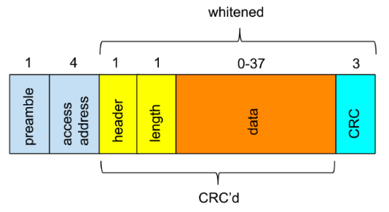

### Bit Order and Bytes

Packets are transmitted bit by bit, but they are composed of bytes of data. Transmitted with the least significant bit first. Therefore 0x80 is transmitted as 00000001, whereas 0x01 is transmitted as 100000000. Most multiple-byte fields are transmitted least significant octet first.

### Preamble

First 8 bits of a packet are either 01010101 or 10101010. The receiver uses these values to set its automatic gain control and determine the frequencies being used for the zero and one bits. The determination of whether the preamble is 01010101 or 10101010 is determined by the first bit of the access address that is transmitted: if first bit of access address is a 0 then 01010101 if 1 then 10101010.

### Access Address

Next 32 bits are access address. Either advertising access address or data access address. The advertising access address is used when broadcasting data or when advertising, scanning, or initiating connections. The data access address is used in a connection. Radio picks up background radiation and typically once every couple minutes will receive a preamble (even with no other device nearby). The access address helps reduce probability of random noise causing a pseudo-packet to be received.

*Correlation of the access address:* Link Layer keeps a copy of all the possible bits that have been received for the last 40 µs and check each time a new bit is shifted into this register to see if this sequence of bits now matches the expected preamble and access address.

For advertising channels, the access address is a fixed value: 0x8E89BED6.

Rules for data access address:

There cannot be more than six zeros or ones anywhere in the access address.

The packet also has to be different from the advertising access address by at least 1 bit.

No repeating patterns (each octet must be different)

There should be no more than 24 bit transitions, stopping the use of an alternating bit seq.

There must be at least 2 bit transitions in the last 6 bits, to ensure that just before the header starts that there are bit transitions, just in case the header whitens to a long seq of bits

There are approximately 231 possible uniquely valid random access addresses. It is possible to have about 2 billion BLE devices within range of one another. The random access address for data channels also limits an attacker’s ability to determine which two devices are in a connection by just receiving this access address.

### Header

The contents of the header depends on whether the packet is an advertising packet or a data packet. For the advertising packet, the header includes the advertising packet type as well as some flag bits to specify whether the packet includes public or random addresses. There are seven advertising packet types, each having a different payload format and behavior:

* ADV_IND: General advertising indication
* ADV_DIRECT_IND: Direct connection indication
* ADV_NONCONN_IND: Nonconnectable indication
* ADV_SCAN_IND: Scannable indication
* SCAN_REQ: Active scanning request
* SCAN_RSP: Active scanning response
* CONNECT_REQ: Connection Request

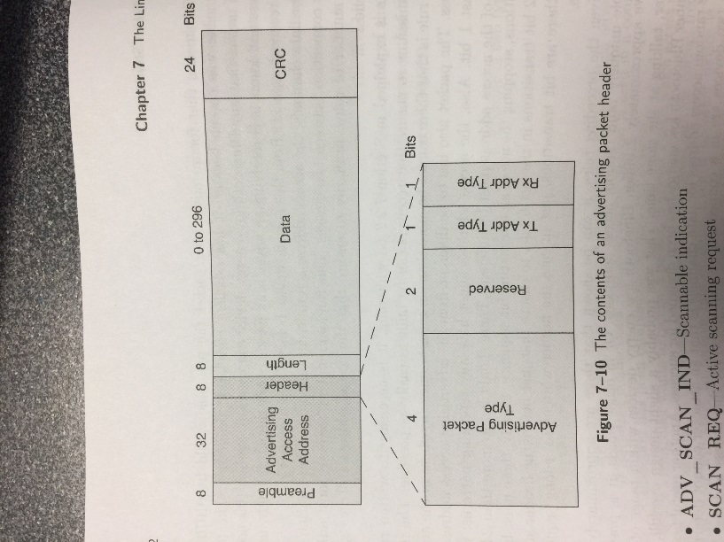

The header for data packets includes bits to enable the reliable delivery of packets, manage low power, and route the payload into either the local controller or to the host.

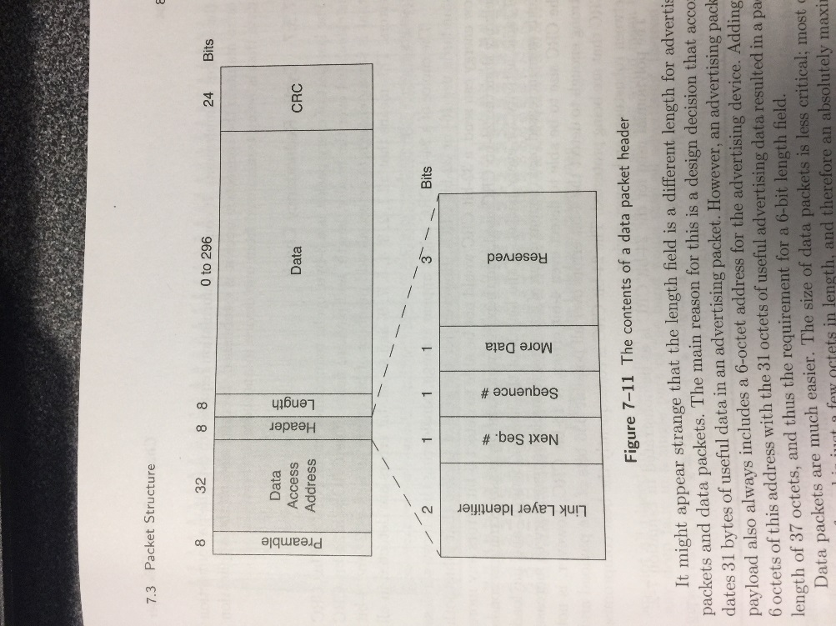

### Length

For advertising packets, the length field is 6 bits with valid values from 6 to 37. For data packets, it’s 5 bits in length with valid values from 0 to 31. An advertising packet’s payload also always includes a 6-octet address for the advertising device. For data packets, if the packet is encrypted, it includes a 4-octet message integrity check value, shortening the actual data in the payload to just 27 octets. To keep the design of the Link Layer as simple as possible, unencrypted packets are not allowed to be longer than this 27-octect limit.

### Payload

Data

### Cyclic Redundancy Check

A 3-byte cyclic redundancy check is used (CRC). The CRC is calculated over the header, length and payload fields.

## Channels

Separated by 2 MHz.



### Frequency Hopping

Because the number of data channels is 37, which is a prime number, the hopping algorithm is very simple:

$$f_{n+1} =\left(f_{n}+hop\right) mod 37$$

The *hop* value is a value that can range from 5 to 16; it is added onto the last frequency modulo 37 every time the frequency-hopping algorithm is used. This means that every frequency will be used with equal priority, regardless of the hop value. Implemented by adding the *hop* value, comparing the value with 36, and if it is greater than this, subtracting 37.

### Adaptive Frequency Hopping

Allows for a given packet to be remapped from a known bad channel to a known good channel so that the interference from other devices is reduced. A channel map of good and bad channels is kept in both devices. If the channel that would have been chosen by using the equation is a good channel, then that channel is used; if the channel that would have been chosen is a bad channel, then it is remapped onto the set of good channels. A minimum of two data channels must be marked as good by a master. Host can inform controller of the current channel conditions. The information could come directly from the interfering radio in the device or it could come from something much more exotic. Most Bluetooth controllers can also perform passive band scanning to determine the location and extent of interference and act on this without any input from the host.

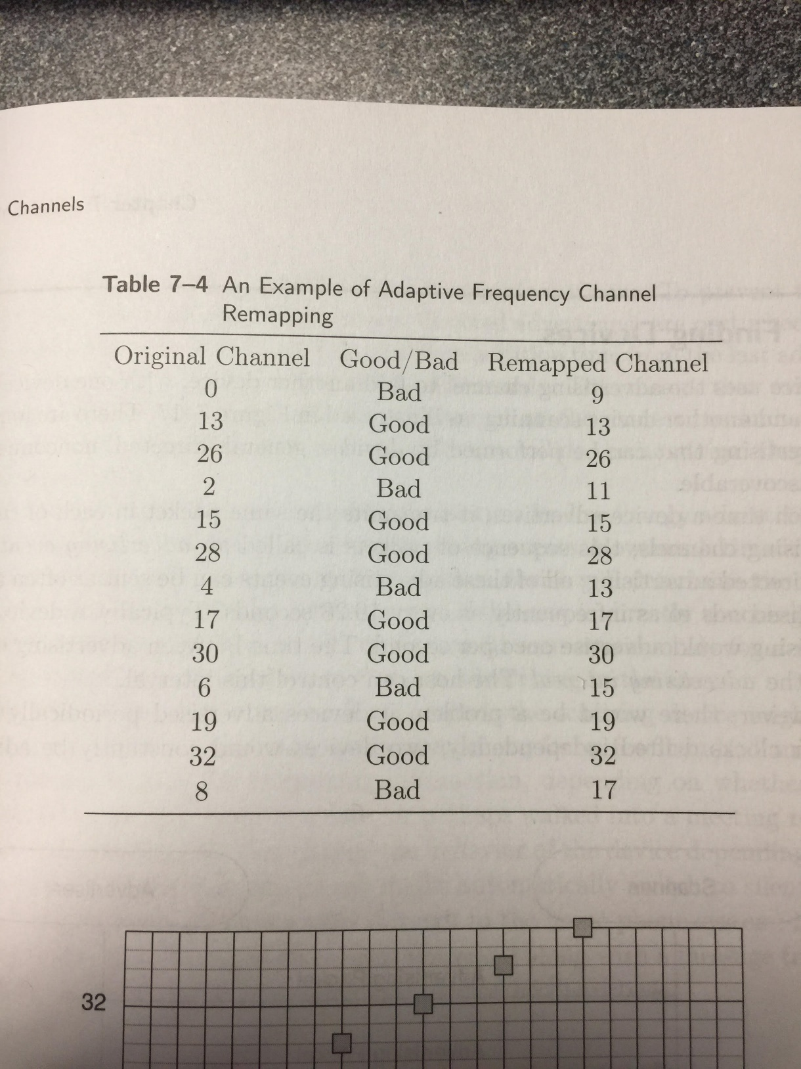

## Finding Devices

Uses advertising channel to find another device, with one device advertising and another device scanning. There are four types of advertising that can be performed by devices: general, directed, nonconnectable, and discoverable. Each time a device advertises, it transmits the same packet in each of the three advertising channels; this sequence of packets is called an *advertising event*. Typically, a device that is advertising would advertise once per second. The time between advertising events is called the *advertising interval*. The host can control this interval. All advertising events, except directed advertising, are perturbed by a random addition time from the last advertising event of somewhere between 0 and 10 ms.

### General Advertising

Device can be scanned by a scanning device or go into a connection as a slave when it receives a connect request. General advertising can be sent by a device that has no other connections.

### Direct Advertising

Sometimes a device needs to make a connection with another device quickly. For a slave to do this, it must advertise. These packets contain two addresses: the advertiser’s address and the initiator’s address. An initiating device that receives a direct advertising packet addressed to itself immediately sends a connect request packet in response. When using directed advertising, a device cannot be actively scanned. Also, directed advertising packets cannot have any additional data in the payload of the packet; they contain only the two addresses needed, and nothing more.

### Nonconnectable Advertising

Used by devices that are broadcasting data and have no intention of being either scannable or connectable. This is the only type of advertising that a device equipped with only a transmitter can use. Can only transition between the advertising state and the standby state.

### Discoverable Advertising

Cannot be used to initiate a connection, but it can be used to allow another device to scan the advertising device. This means that the device is discoverable, both for advertising data and scan response data, but cannot be connectable. This is an advanced form of broadcast data, whereby the dynamic data can be included in the advertising data, whereas static data would be included in the scan response data. Discoverable advertising will never enter the connection state; instead, it moves back to the standby state when it is stopped.

## Broadcasting

For a device to be considered a broadcasting device, it must include some useful data in the advertisement. Can broadcast with three of the four advertising events: general advertising, nonconnectable advertising, and discoverable advertising. Broadcast data can be received by any passive or active scanning devices nearby. Broadcast data cannot be acknowledged. A broadcasting device also doesn’t know if any device received its data or if any device is attempting to listen to the data. Broadcasting must be considered to be an unreliable operation.

## Creating Connections

Connections use adaptive frequency hopping to be robust and a very low duty cycle to keep the power consumption as small as possible. A connection uses the data channels to reliably send information, in two directions, between two devices.

The first step in creating a connection is for one device to advertise by using a connectable advertising event and for another device to initiate a connection to the advertising device. To make a connection, either the general advertising event or the direct advertising event types myst be transmitted by the advertiser. When the initiator receives the advertising packet from the correct device, it sends a connect request back to the advertiser. This connection request packet includes everything that is needed at the start of the connection, which is presented in the following list:

* 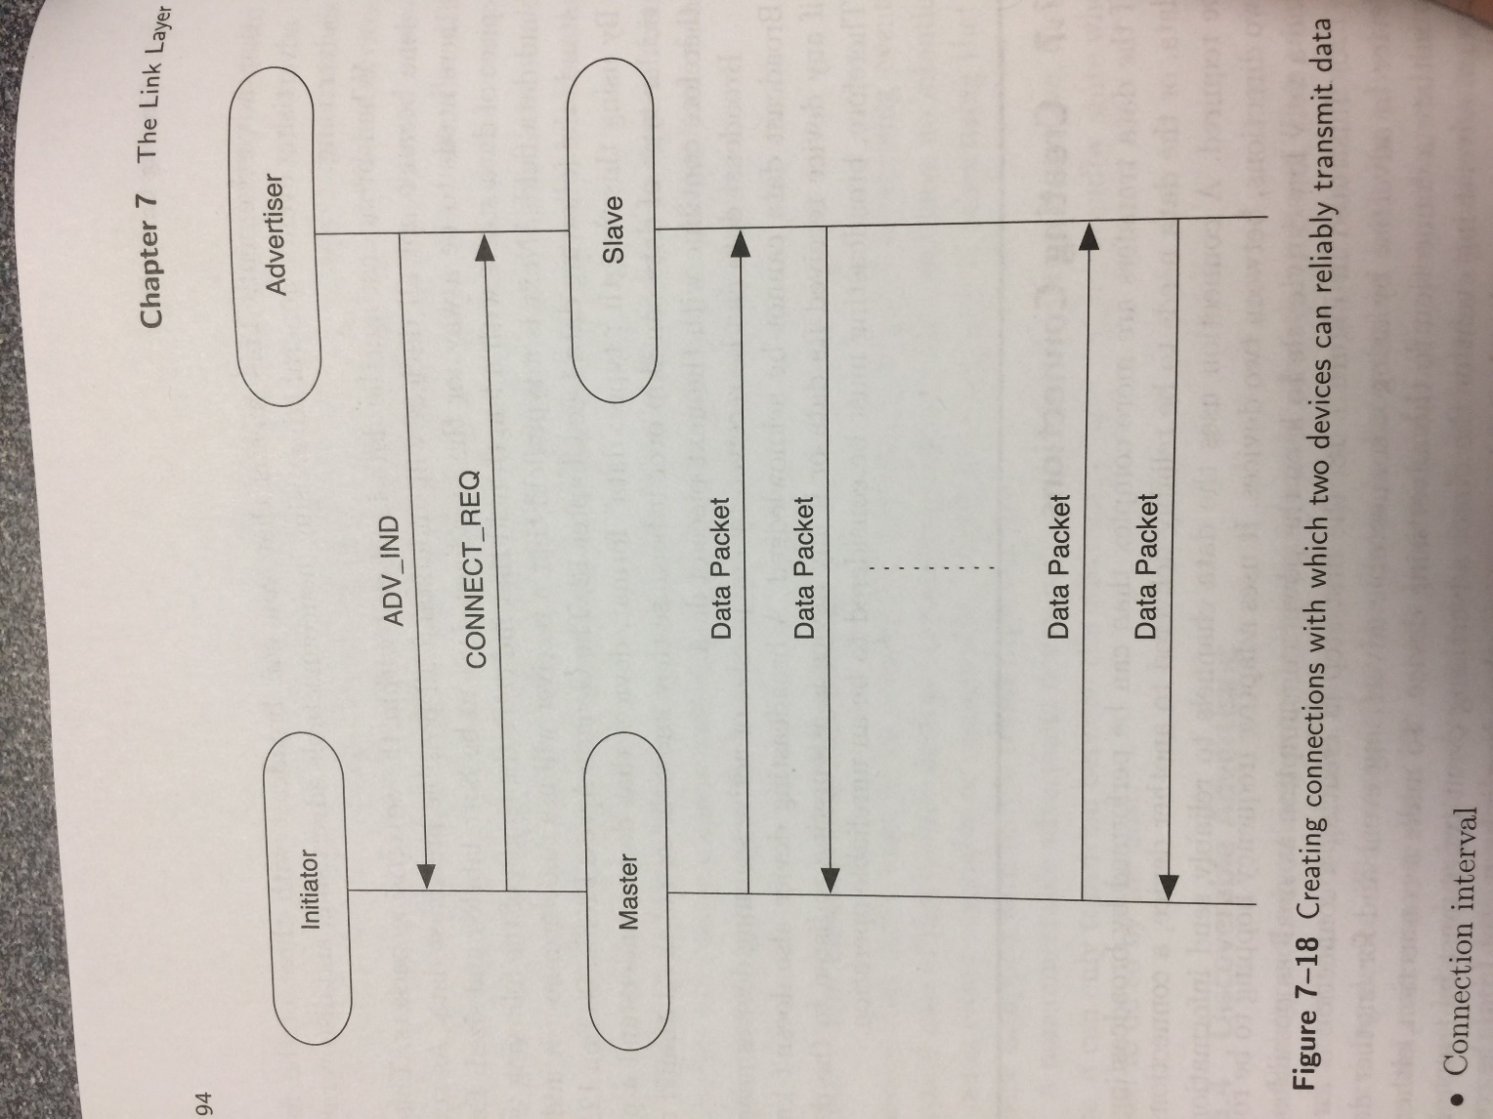Access Address to be used in the connection
* CRC initialization value
* Transmit window size
* Transmit window offset
* Connection interval
* Slave latency
* Supervision timeout
* Adaptive frequency-hopping channel map
* Frequency-hop algorithm increment
* Sleep clock accuracy

### Access Address

The master always determines the access address that will be used in the connection. The value is random (with some rules). If the master has multiple slaves, it will choose a different random access address for each slave.

### CRC Initialization

Another random value chosen by the master. Random because it is possible for two masters in the same area to use the same access address to talk to different slaves.

### Transmit Window

Transmit window starts after the end of the connection request packet, plus an additional mandatory delay of 1.25 ms, plus the transmit window offset. The transmit window offset can have any value from 0 to the connection interval, in multiples of 1.25 ms. At the start of the transmit window, the slave device opens up its receiver and waits for a packet to come from the master. It this packet is not received within the transmit window size, the slave aborts and tries again one connection interval later. Once the connection request has been transmitted, the master believes it has a connection; the connection has been created but not proven to have been established. Once the slave receives the connection request, it believes it is also in a connection; again, the connection has been created but not proven to have been established. The host is immediately notified that it is in a connection and sends data down to the controller to be sent after the 1.25 ms delay. The connection is only considered established once a packet has been acknowledged. Establishment changes the link supervision timeout from just six connection timeouts to the value in the connection request message.

### Connection Events

When in a connection, the master has to transmit a packet to the slave once every connection event. A connection event is the start of a group of data packets that are sent from the master to the slave and back again. A connection event is always conducted on a single frequency, with each packet transmitted 150 µs after the end of the last packet.

*Connection Interval* determines how frequently the master will talk to the slave; it is the time between the start of the last connection event and the start of the next connection event. This can be any period from 7.5 ms to 4 s in multiples of 1.25 ms.

*Slave latency* determines how infrequently the slave is allowed to talk to the master. This is a multiple of the connection interval and determines how many times the slave can ignore the master before it is forced to listen. This must be quicker than the supervision timeout.

Each connection event is a connection interval apart and no packets are allowed to be sent from the master of the slave between connection events.

For example, if the connection interval is 100 ms and the slave latency is 9, the slave can ignore the master for 9 connection events but is forced to listen for the 10th, or once every second. The supervision timeout must be a minimum of 1010 ms. It is recommended that the slave is given six opportunities to listen. Therefore, in the above example, the supervision timeout should be a minimum of 6 seconds, allowing the slave to listen a minimum of six times before the link is dropped.

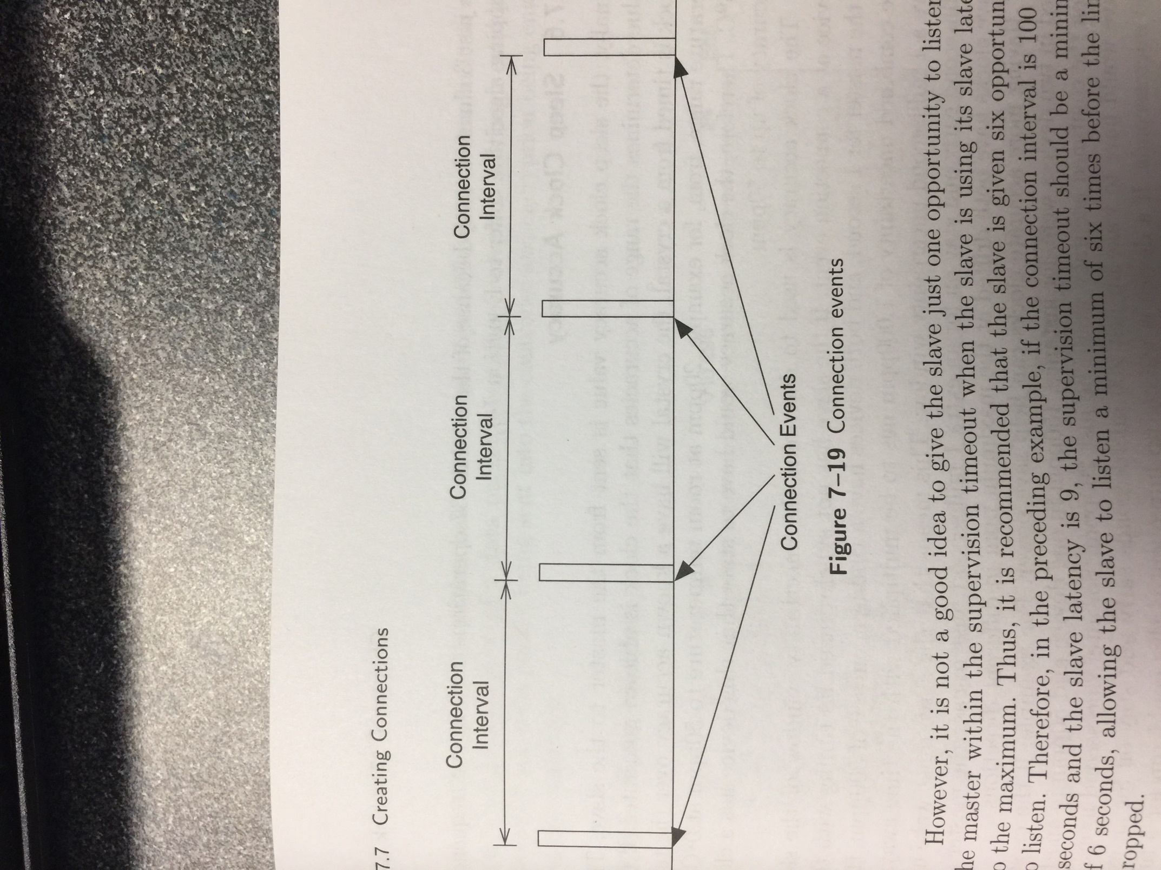

### Channel Map

The adaptive frequency-hopping channel map is a bit mask of the data channels that are known to be good or bad. The channel map is 37 bits in length, with ones meaning a good channel and zeros meaning bad channel. Frequency-hopping algorithm is used before the adaptive remapping algorithm is used.

### Sleep Clock Accuracy

Sent from the master to the slave. The clock accuracy is used to determine the uncertainty window of the slave device at a connection event. The combined timing accuracy will indicate how early the slave must wake up before a connection event and how long it must stay on after a connection event in case the master and slave clocks have both drifted at the maximum ppm in different directions. This is used when the slave has not synchronized its timing recently. The higher the accuracy the less time the device has to wake before a connection event and stay on after one.

## Sending Data

Data packets are sent at connection events. Data packets are private communications between to devices rather than broadcast communications to any device that is listening. A zero-length payload in a data packet is an empty packet; it has no application data but can still include some info from the packet header.

### Data Header

* Logical link identifier (LLID)
* Sequence number (SN)
* Next expected sequence number (NESN)
* More data (MD)



There is no “packet is encrypted” bit because this is a modal property of the connection, just like for the adaptive frequency hopping or the connection event intervals.

### Logical Link Identifier

Determines if the packet contains one of the following types of data:

* Link Layer control packet (11) – This is used for managing the connection
* Start of a higher-layer packet (10) – Or for a complete packet
* Continuation of a higher-layer packet (01)

If the packet is a Link Layer control packet it is passed directly to the Link Layer control entity. All other packets are to or from the host. The host can send larger packets but they are segmented. Packet is labeled as either a start or continuation packet. The Link Layer doesn’t require knowledge of the ultimate size of the packet at the start of the packet. The number of continuation messages is not fixed at the start of the message. It is possible to always send zero-length continuation messages without any impact on the higher layer data. Simple acknowledgement messages can be sent as zero-length continuation messages. These zero-length continuation packets are known as empty packets.

### Sequence Numbers

To enable reliable transfer of data, all data packets have sequence numbers. Each new data packet has a different sequence number from the last data packet’s sequence number, with the first packet in a connection having a sequence number of zero. Can determine if the next packet that is received is a retransmission of the previous packet. In data packets, there is a single bit for the sequence number, starting at zero alternating between one and zero for each new data packet.

### Acknowledgement

To perform acknowledgement of a data packet, a single bit is used. This is called the *next expected sequence number bit*.

### More Data

Signals to peer device that the transmitting device has more data ready to be sent. The peer receiving device upon seeing the more data bit set in a received packet should continue to communicate in this connection event. Automatically extends connection events while there is still data to be sent. Also quickly closes connection events for which there is no more data to be sent.

The sequence number and next expected sequence number are always in lock-step with one another. This ensures that packets are always reliably delivered and in order. A packet is not considered to be received when the CRC fails to verify that the contents of the packet have been received correctly. It is also possible to use the next expected sequence to enable flow control. If there is not enough buffer space for the next message it will not update the next expected sequence number, effectively pushing the buffering requirements onto the sending device and away from the receiving device.

If there are two failures to receive a packet on the same connection event, the two devices will stop using that connection event. The devices will then resynchronize at the next connection event and try again. This means that if a given channel is being blocked due to interference, then very quickly the two devices will discover this interference and stop using that channel. By moving to a new channel quickly, the interference caused by transmitting on the blocked channel is mitigated almost immediately, but data is still delivered to the other device very quickly at the next connection event.

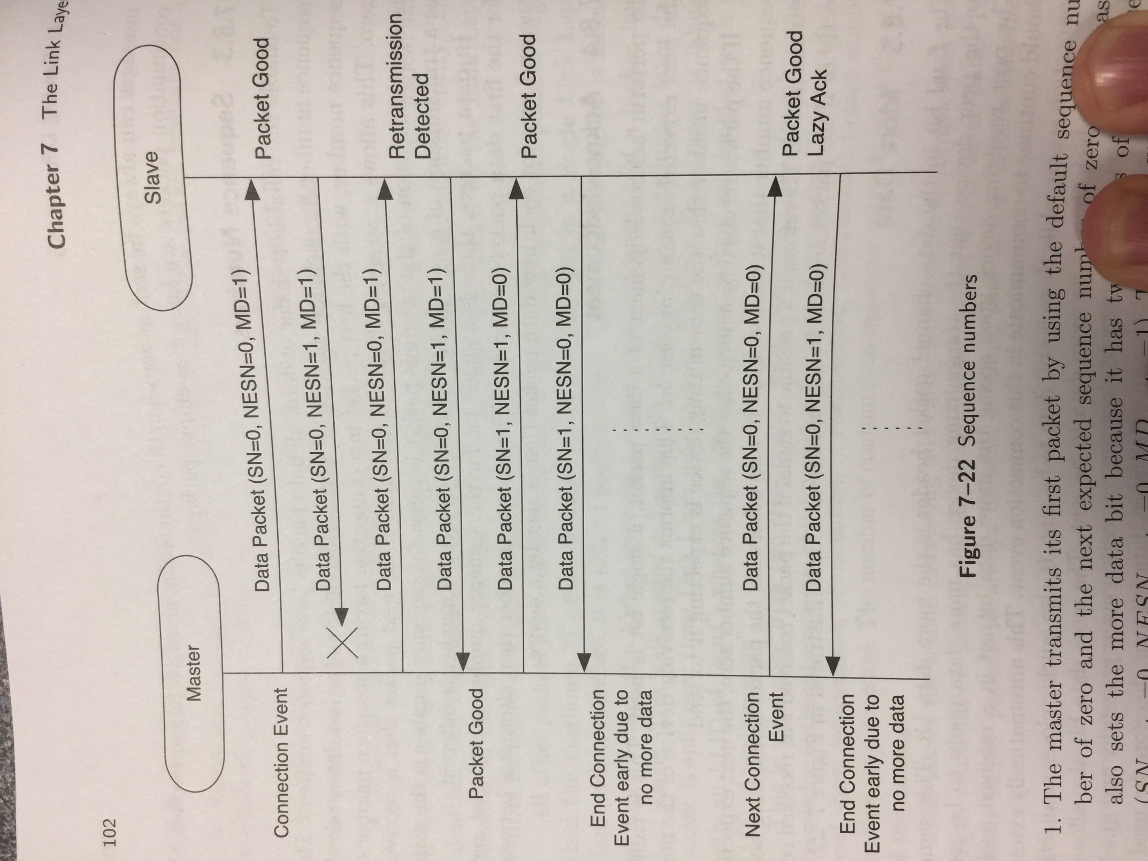

## Encryption

Data within the payload can be encrypted. Encrypted packets also include a message integrity check value that ensures the data is authenticated. Encrypted packets also include a packet counter to stop replay attacks.

### AES

All encryption and authentication in BLE is built around AES. In BLE 128-bit key size and 128-bit data blocks are used. The AES encryption block takes two inputs (128-bit key value and 128-bit block of plain-text data) and generates one output (128-bit block of encrypted data). It is most efficient to set up the key once and then pass in different plain-text blocks and encrypt them quickly. One key for multiple blocks. AES is used for four basic functions:

* Encrypting payload data
* Calculating a message integrity check value
* Signing data (defined by Security Manager)
* Generating private addresses (defined by the Generic Access Profile)

### Encrypting Payload Data

Payload is split into 16-byte blocks, and for each block a cipher bit stream is generated. This cipher bit stream is then XOR’ed with the plain text. Standard encryption algorithm for any size key and any size message.

The Ax­ encryption blocks are used. These are initialized plain-text blocks that have a known format and include a *nonce* composed of a packet counter, a direction bit, and an initialization vector (IV). || means concatenation.

*Nonce = Packet Counter* || *Direction* || *IV*

*Packet Counter*: 39-bit value that is incremented for each new non-empty packet htat is transmitted. Always starts with zero when encryption is enabled. Empty packets are not encrypted.

*Initialization Vector*: random value that is 64 bits in length, where 32 bits of this vector are contributed by each device in the encrypted link.

Therefore, the *nonce* is 13 bytes in length.

More info on page 106-107

This encrypted payload is then sent to the peer device. The peer device knows the shared secret—the key value—it can decrypt the message by using the same packet counter, direction, and IV values. When the encrypted payload is sent, the CRC is calculated over the encrypted payload, not the original payload blocks. The header and length fields of the data packet are never encrypted.

### Message Integrity Check

Used to authenticate the sender of the data packet and is inserted between the data and the CRC. This ensures that the encrypted packet is sent by the peer device and not by a third-party attacker.